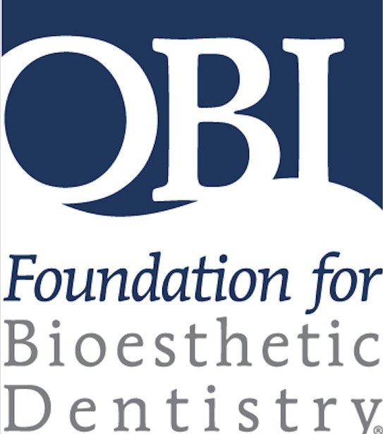
WELCOME!
OBI FOUNDATION
2026 ANNUAL SESSION
October 2nd & 3rd, 2026
EXHIBITOR / SPONSOR / ADVERTISING PROSPECTUS

Whether you are a past exhibitor/sponsor/advertiser or considering participating with us for the first time, we look forward to your attendance at this year’s OBI Foundation 2026 Annual Session in NASHVILLE!

In addition to displaying your organization's products and services as an exhibitor, there are networking, sponsorship and marketing opportunities available for this years’ event. OBI Foundation is oﬀering a wider range of sponsorship opportunities in 2026 with the benefit of increased access and visibility of organizations throughout the Annual Session. We have a great meeting planned that includes more opportunities for interactions with attendees than ever before.

With the attractions of Nashville and following the success of last year’s meeting, we anticipate in excess of 150 attendees in Nashville in 2026.
Our goal is to help you promote your company in a variety of ways to a great community of doctors, lab technicians, and team members!

Please let us know how we can facilitate your attendance. We are here to help!

Your OBI Oﬃce Team, Laura Jones & Emily Allen

HOTEL ACCOMMODATIONS & EVENT LOCATION:
There are several lodging options in Boston (please see our digital handbook for suggestions).

The event space:
Residence Inn by Marriot Nashville Downtown/Convention Center

EXHIBITOR / SPONSOR / ADVERTISING APPLICATION DUE DATE:
JULY 1st, 2026
Send to obi@bioesthetics.com

EXHIBITOR LEVEL | BENEFITS
GOLD $1,600 | ~Full page (8.75” wide x 11.25” tall) advertisement in Annual Session handbook for all attendees  ~Exhibit booth for 2 days of Annual Session (includes one 6ft table with standard drayage with two chairs, one waste basket)  ~Company logo and link to website posted on OBI Foundation website  ~Registration for 2 company representatives for 2 days  ~Attendance at the President’s Dinner – Friday night  ~Sponsorship opportunities (ask the OBI Team for more information)
SILVER $1,200 | ~Half page (8.75” wide x 5.75” tall) advertisement in Annual Session handbook for all attendees  ~Exhibit booth for 2 days of Annual Session (includes one 6ft table with standard drayage with two chairs, one waste basket)  ~Company logo and link to website posted on OBI Foundation website  ~Registration for 2 company representatives for 2 days  ~Sponsorship opportunities (ask the OBI Team for more information)

EXHIBITOR INSTALLATION HOURS:
Set-Up: Thursday, October 1st, 2026 | 1:30 pm – 5 pm
Tear-down: Saturday, October 3rd, 2026 | 4:00 pm - 6:00 pm
Complete Removal from Exhibit area by Saturday, October 3rd, 2026 | 6:00pm

EXHIBIT FEE DOES NOT INCLUDE:
- Cleaning and maintenance of individual booth and aisles
- Additional drayage or placement of display equipment
- Decoration and related services
- Labor (i.e. carpenters, electricians, draper persons and/or upholsterers)
- Storage of any exhibit related materials
- Electric power or additional lighting
- Internet

HOTEL FEES:
- Audio Visual Exhibitor Services –
-please contact Emily at the OBI oﬃce for specific requirements @ obi@bioesthetics.com or 521.245.2808
- Shipped Materials – Package Handling Fees –
please contact Emily at the OBI Oﬃce for specific information @ obi@bioesthetics.com or 521.245.2808

USE OF EXHIBIT SPACE:
Subletting your booth with another company is strictly prohibited.

NEXT STEPS:
Once your application and payment are received you will be contacted by OBI Foundation with additional information about your participation and selection of booth space.
Please remember to send your company logo and description to be included in the conference Program/Handbook.

LOSS OR DAMAGE OF MATERIAL:
Each exhibitor must make provisions for safeguarding company materials, equipment and booth displays at all times. OBI Foundation is not responsible for loss or damage of any material by any person or for any cause.

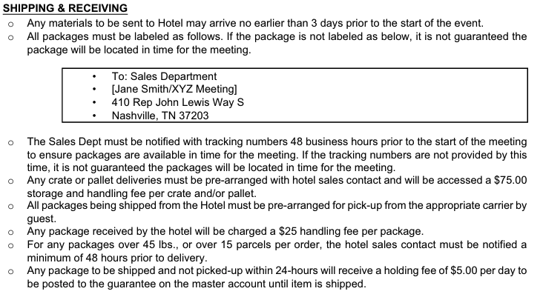
SHIPPING AND DELIVERY INFORMATION to Nashville, TN

SPECIAL REQUESTS:
If you have a special request regarding booth placement in the exhibit hall, such as sister companies being grouped together, let us know in advance and every attempt will be made to accommodate your request. Keep in mind that booth placement is first come first serve, we will provide you with a schematic of the floor and you may choose your booth placement accordingly... Note: All additional services are available at the exhibitors’ own expense. The exhibit space granted under the terms of this agreement is to be used exclusively by the exhibitor to present their products and services and is not to be sub-divided or shared with another company. Exhibitors are responsible for the safety and security of their exhibits at all times. OBI Foundation does not provide security.

PRINTED & ADVERTISING MATERIALS DEADLINE: July 1st, 2026
To ensure that your company’s advertisement and logo are recognized in the printed meeting materials, conference handbook, and elsewhere at the Annual Session, OBI oﬃce must receive your completed registration form and payment no later than July 1st, 2026 together with your 60-word product/service description.

ADVERTISING LEVEL | BENEFITS
FULL PAGE $1,000 | ~Inclusion in the Annual Session handbook for all attendees  ~Logo and link on OBI Foundation website
HALF PAGE $ 500 | ~Inclusion in the Annual Session handbook for all attendees  ~Logo and link on OBI Foundation website

Print copy details are as follows:
Full Page - 8.75” wide x 11.25” tall (there's a .125” bleed on all sides) Half Page - 8.75” wide x 5.75” tall (there's a .125” bleed on all sides) 300 DPI for .jpg files, .pdf, .eps, .ai, .psd preferred.
Flattened, packaged, and outlined
Please submit your advertising copy electronically to the OBI oﬃce at: obi@bioesthetics.com If you have questions, please call the OBI oﬃce on 541-245-2808

ADDITIONAL PROMOTIONAL OPPORTUNITIES:
OBI oﬀers business organizations other sponsorship opportunities.
- Gift Certificate donations for your company products or services to our scholarship fundraising event on Friday evening, October 2nd, 2026 during the President’s Dinner; Raﬄe prize donations.
Contact the OBI oﬃce on 541-245-2808 for more details.

SPONSORSHIP OPPORTUNITIES DEADLINE: JULY 1st, 2026
OBI oﬀers business organizations sponsorship promotional opportunities.
There are a limited number of corporate sponsorship opportunities with maximum exposure to attendees at the OBI Annual Session.
Sponsor partners benefit from:
  - HALF PAGE (8.75” X 5.75”) advertisement in the Annual Session Conference Program Handbook
  - Company logo and link to company’s website posted on the OBI Foundation website

SPONSORSHIP LEVEL | SPONSOR BENEFITS
$3,000 – Academy Session Audio Visual  $2,000 Morning & Afternoon Refreshments: FRI or SAT  $4,000 Lunch (FRI / SAT)  2,500 – Attendee Flash Drives with logos  $1,500 Attendee Pens with logos | FULL PAGE (8.75” X 11.25”) advertisement in the Annual Session Conference Program Handbook  Registration for one company representative for 1 day  One 5-minute presentation in the Session room  HALF PAGE (8.75” X 5.75”) advertisement in the Annual Session Conference Program Handbook  Company logo and link to company’s website posted on the OBI Foundation website

Sponsor organizations, to ensure that your company advertisement and logo are recognized in the printed meeting materials, conference handbook, and elsewhere within the Annual Session, the OBI oﬃce must receive your completed registration form and payment no later than July 1st 2026, together with your corporate logo, advertising, copy, and 60-word product/service description. Please contact the OBI Oﬃce team for more information on these exciting opportunities!

CANCELLATION POLICY:
All cancellations must be made in writing and can be emailed, faxed, or mailed.
Exhibit space, advertising or sponsorship agreement canceled prior to Friday, July 31, 2026 will incur an administrative cancellation fee of $100.00.
Cancellation of Exhibit space, advertising or sponsorship agreement after Friday, July 31, 2026 but prior to Friday August 31st, 2026 will result in a 50% refund on the original Exhibit space, advertising or sponsorship fee paid.
Any Exhibit, advertising, sponsorship or hotel room cancellations after August 31st, 2026 will not be eligible for a refund.
If a company fails to attend the event they will be considered a “No Show” and will not be eligible for a refund.

Registration Deadline is July 1st, 2026

2026 Annual Session, Nashville, TN
Exhibitor, Advertiser and Sponsor Registration
October 2nd & 3rd, 2026
HOTEL - Residence Inn by Marriot Nashville Downtown/Convention Center

Please complete the form below to register for the OBI Foundation Annual Session as an EXHIBITOR, ADVERTISER or SPONSOR.

REGISTRATION CLOSES: JULY 1st, 2026

EXHIBIT, ADVERTISING, SPONSOR SELECTION:
Please check one:
Exhibitor { } $1,600 { } $1,200 Advertising { } $1,000 { } $500
TOTAL PAYMENT DUE:

$

Sponsorship { } $1,500 { } $2,000 { } $3,000 { } $3,500 { } $5,000

COMPANY NAME:
COMPANY CONTACT:
EMAIL ADDRESS: PHONE #:
REPRESENTATIVE NAME(S)

RETURN THIS COMPLETED REGISTRATION FORM WITH:
- Corporate LOGO
- Advertising copy to meet specification
- 60 words or less product service description
- Payment: Check or Credit Card (details below)

CREDIT CARD INFORMATION:
NAME ON CARD:
CREDIT CARD NUMBER:
EXPIRATION DATE: CID #:
AUTHORIZING CORPORATE SIGNATURE:

RETURN TO OBI at: Email: obi@bioesthetics.com : Or FAX : 541-245-9445 Mailing address: 126 W Main Street, Union, MO 63084
Oﬃce #: 541-245 2808 / URL : bioesthetics.com

